**Big Mountain Resort – Final Report**

**Background.** Big Mountain Resort (BMR) extends on 3,000 acres of skier and rider accessible terrain. The resort offers access to 105 trails, vast bowl and tree skiing, all serviced by 11 lifts, 2 T-bars and 1 magic carpet for novice skiers. BMR, recently implemented an additional chair lift to streamline the transfer of visitors across the mountain. The new chair lift increased BMR operating costs of $1,540,000

Despite the increase of the operating costs, Top Management and investors want to keep business profit margin at 9.2%. To increase revenues Big Mountain Resort could increase the price of adult weekend lift ticket. Business and mountain information and amenities for Big Mountain Resort and other US 329 US ski resorts were gathered and compared against each other to determine whether increasing lift ticket price is a valid solution.

**Dataset Features.** The available data included resort’s name, location (region, state), mountain information (summit elevation, base elevation, vertical drop, average snowfall, area accessible to snow making machine), amenities (total number of runs, skiable terrain, longest run length, number and type of lifts, number of terrain parks, night skiing accessible area), how many years the resort has been open, weekend and weekday lift ticket prices, the total number of days the resort was open in the previous season and how many days the resort was expected to be operative in the next season.

**Method.**

1. Missing number were filled with either 0 or the mean value.
2. Histogram plot for the adult weekend lift ticket price was constructed to display where Big Mountain Resort stands in comparison to the competitors.
3. Linear regression models were built and tested to quantify its accuracy
4. The best model was utilized to predict adult weekend lift ticket price.
5. Prediction was then compared with the current value to provide a recommendation.

**Results.**

* **Adult Weekend lift ticket price.** Exibit1 shows the distribution of the price of the adult weekend lift ticket.Table 1 reports model performance, current and predicted prices for the weekend lift ticket. The model included 22 variables ('summit_elev', 'vertical_drop', 'trams', 'fastEight', 'fastSixes', 'fastQuads', 'quad', 'triple', 'double', 'surface', 'total_chairs', 'Runs', 'TerrainParks', 'LongestRun_mi', 'SkiableTerrain_ac', 'Snow Making_ac', 'daysOpenLastYear', 'yearsOpen', 'averageSnowfall', ’AdultWeekday', 'projectedDaysOpen', 'NightSkiing_ac').

**Exhibit 1.**

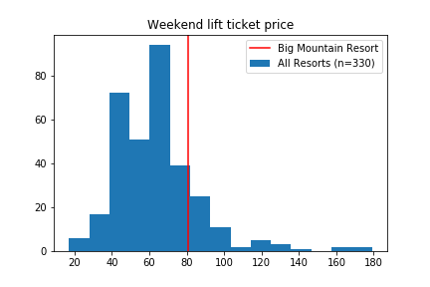

|  |  |  |  |
| --- | --- | --- | --- |
| **Model Accuracy** |  | **Current Price** | **Predicted**  **Price** |
| Mean Absolute Error: $5.12  Variance Explained Score: 0.93 |  | $81 | $87.5 |
| **Table 1.** | | | |

**Results summary.**

1. The best model predicting the **adult weekend lift ticket price** accounted for 93% of the variability observed in the dependent variable. The model predicted that lift ticket price should be increased from $81 to $87.5.

**Recommendation.**

I recommend Top Management to increase the adult weekend lift ticket price from $81 to $87-88.

**Conclusion**

Big Mountain Resort operating costs have increased due to the construction of the lift chair. My analysis suggests that Big Mountain Resort could improve its revenues and, therefore, hit the profit margin target of 9.2%, by increasing the adult weekend lift ticket price.